STEPS TO INSTALL GRAPHQL

**Step1:** download Visual Studio Community edition from link .: <https://visualstudio.microsoft.com/vs/community/>

**Step2:**After Download open Visual Studio setup.exe and select below listed packages

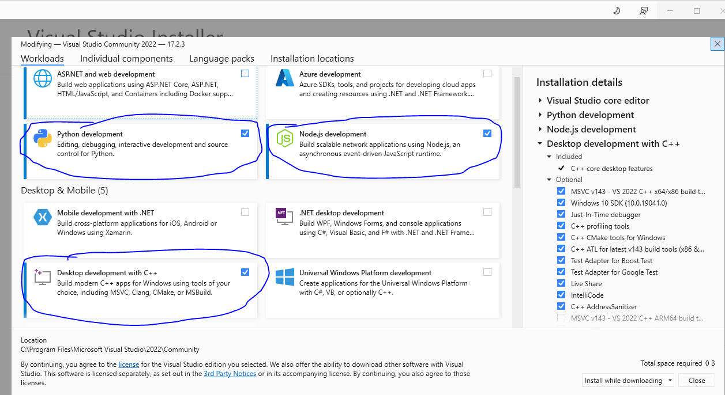

**Step3:**click on individual component from same window and in search box type MSV from results select MSVC v14x –VS2022 C++ x64/x86 Build tools latest .

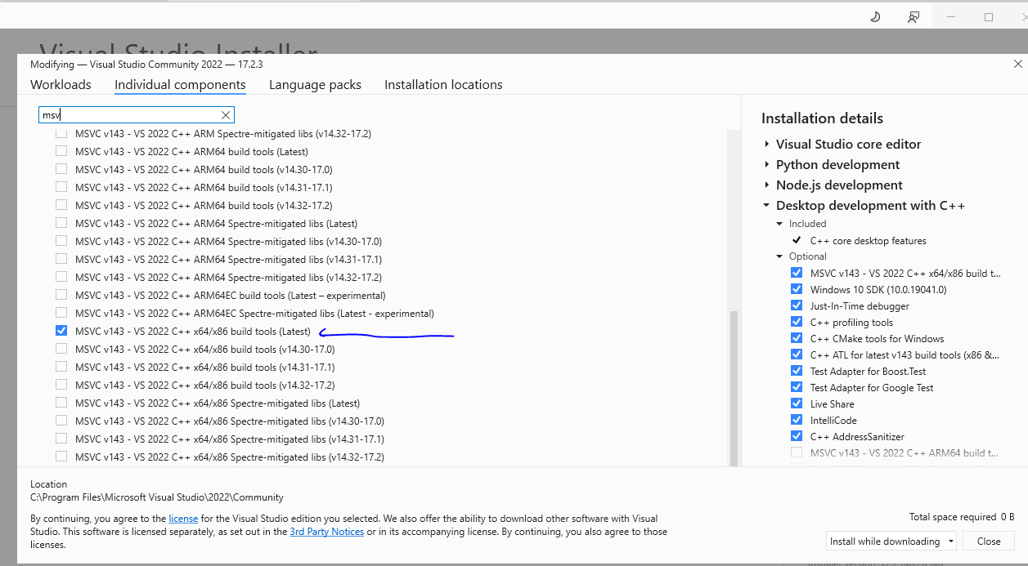

**Step 4 :** download and install windows 10 SDK from below link

<https://developer.microsoft.com/en-us/windows/downloads/windows-sdk/>

step5: open command prompt and type

git clone <https://github.com/bahmutov/todo-graphql-example.git>

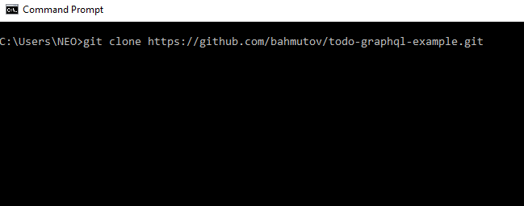

After cloning folder type cd todo and press TAB button and hit Enter

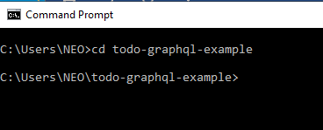

Now type code . to open this folder with vs code

**Step 6:** in Vs Code open new terminal and type npm install and hit enter

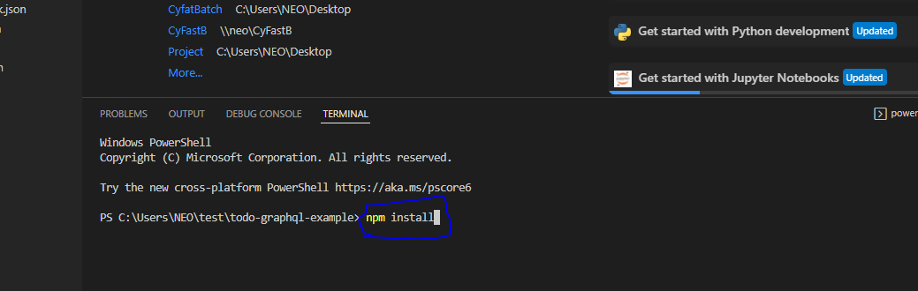

**Step 7 :** after installation of npm type npm run dev and press enter.

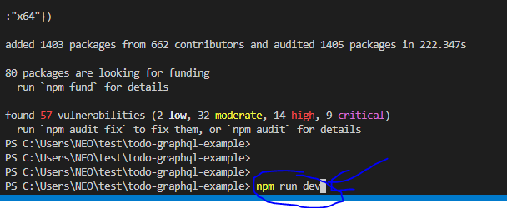

After that enter npm start to start server

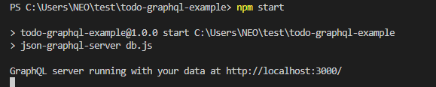

Now open new terminal and type npm run app:built and press enter.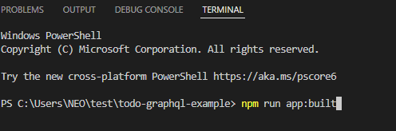

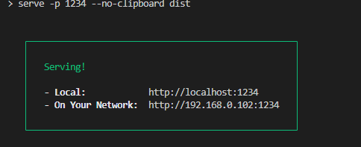

Now open below url in browser

1. For front end - <http://localhost:1234/>
2. For back end - <http://localhost:3000/>

**DONE**